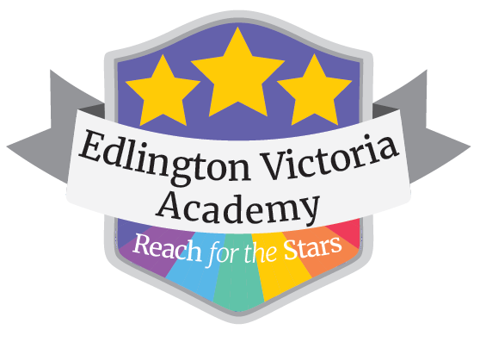
EDLINGTON VICTORIA ACADEMY
Victoria Road, Edlington, Doncaster, DN12 1BN
Telephone 01709 862175
Website: www.edlingtonvictoria.co.uk
Principal: Mrs E Clark

1 September 2021

Dear Parents and Carers

Parent Governor Vacancy

A vacancy has arisen for a parent governor on our Local Governing Board effective from 01 September 2021. I am therefore writing to invite parents of registered pupils to consider standing for the role. The term of office is for 4 years, though governors are free to resign at any time.

While not involved in the operational management of the school, the Local Governing Board plays a key part in the oversight of standards and school improvement, mainly by asking questions and providing an external viewpoint on its work. No special qualifications are required but to be successful in the role, you will be committed to the success of the school and willing to play an active role in the Local Governing Board’s work, contributing with integrity, honesty and objectivity.

While nominations are invited from all those with parental responsibility, the Local Governing Body is particularly looking for a keen interest in Maths or English at the moment and parents with knowledge, skills and experience in this area are particularly encouraged to stand.

You will be expected to:
- Attend six LGB meetings per year meeting at hh:mm for approximately 2hrs
- Prepare for those meetings by reviewing papers, undertaking further reading as necessary and considering any questions or other observations they raise
- Commit to visiting the school at least once during the school day each academic year to monitor key aspects of work
- Attend training to assist you in becoming and staying up to date and effective in your role
- Undergo an enhanced DBS check to confirm your suitability to work with children
- Declare any business or pecuniary interests and accept that these interests together with your name, term of office as a governor, and attendance will be published on the school website.
- Commit to the LGB code of conduct.

In return, you can look forward to: being part of a team, working collectively to ensure all children at the school receive the best quality of education and personal development we can give them; use and enhance existing skills and develop new one; and gain personal satisfaction from knowing you are making a difference for the community.

If you are interested in becoming a parent governor, you are encouraged to contact the Principal/Chair of Governors principal@victoria.doncaster.sch.uk to find out more about the role at this school. Nominations should be submitted on the attached nomination form by 24 September 2021.

Yours sincerely,

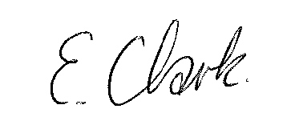

Mrs E Clark
Principal

Governor Nomination Form
Basic Information
Title
First Name
Surname
Previous surname (if
none, please state ”none”)
Date of Birth
Nationality
Country of Birth

Contact information
Address
Postcode
Home telephone no
Mobile telephone no
Email
Preferred form of contact

Are you a parent of a pupil at an academy within Exceed Learning Partnership?  If yes, please state which academy. | Yes / No
Are you a governor, Director, member or local governor (or equivalent) at any other school, academy or Trust?  If yes, please give details. | Yes / No
Are you related to a member of staff, local governor, Director or member within Exceed Learning Partnership or one of its academies?  If yes, please state name and their position/location of association. | Yes / No

Why would you like to become a member/Director/Co-Opted Governor of Exceed Learning Partnership?

Please detail relevant skills, experience and personal attributes you have and how these will make you an effective community governor. (please see role description)

Declaration

I confirm that to the best of my knowledge the information provided is accurate and I know of no reason why I would not be suitable to serve as a Member/Director/Co-Opted Governor of Exceed Learning Partnership (refer to disqualification criteria).

I recognise that my appointment is subject to an enhanced DBS and section 128 check

If appointed, I accept that my name and details about my role as a community governor will be published on Exceed Learning Partnership’s website and the Department for Education public database. My postcode, date of birth, any previous names, nationality and country of birth will also be shared with the Department for Education but will not be published.

Signed Date

Please return to: F.A.O Principal, Edlington Victoria Academy, Victoria Road, Edlington, DN12 1BN
or via email to admin@victoria.doncaster.sch.uk

